**Ideation Phase**

**Define the Problem Statements**

|  |  |
| --- | --- |
| Date | 27 June 2025 |
| Team ID | LTVIP2025TMID59193 |
| Project Name | SmartSDLC – AI-Enhanced Software Development Lifecycle |
| Maximum Marks | 2 Marks |

**Customer Problem Statement Template**

**1. Customer Persona:**

**Describe the type of problem user facingExample:** Software developers, project managers, and students in software engineering.

**2. Problem Description:**

**what is user struggling with?Example:** Users find it time-consuming and challenging to go from vague requirements to working software quickly. They often write unclear requirements, manually fix bugs, or struggle with starter code generation.

**3. Impact of the Problem?**

**how does it effect user productivityExample:** This leads to slower development cycles, unclear communication, frequent rework, and poor quality of deliverables.

**4. Current Alternatives:**

**what are users doing to solve problem?Example:** Using isolated tools like requirement templates, manual bug fixers, or Stack Overflow for code snippets — none of which are integrated or AI-powered.

**5. Why is Solving This Important Now?**

**Explain what is cause?Example:** With increasing demand for faster product delivery and smarter tools, AI-powered SDLC tools are critical for efficient and intelligent development.

Reference Link: <https://miro.com/templates/customer-problem-statement/>

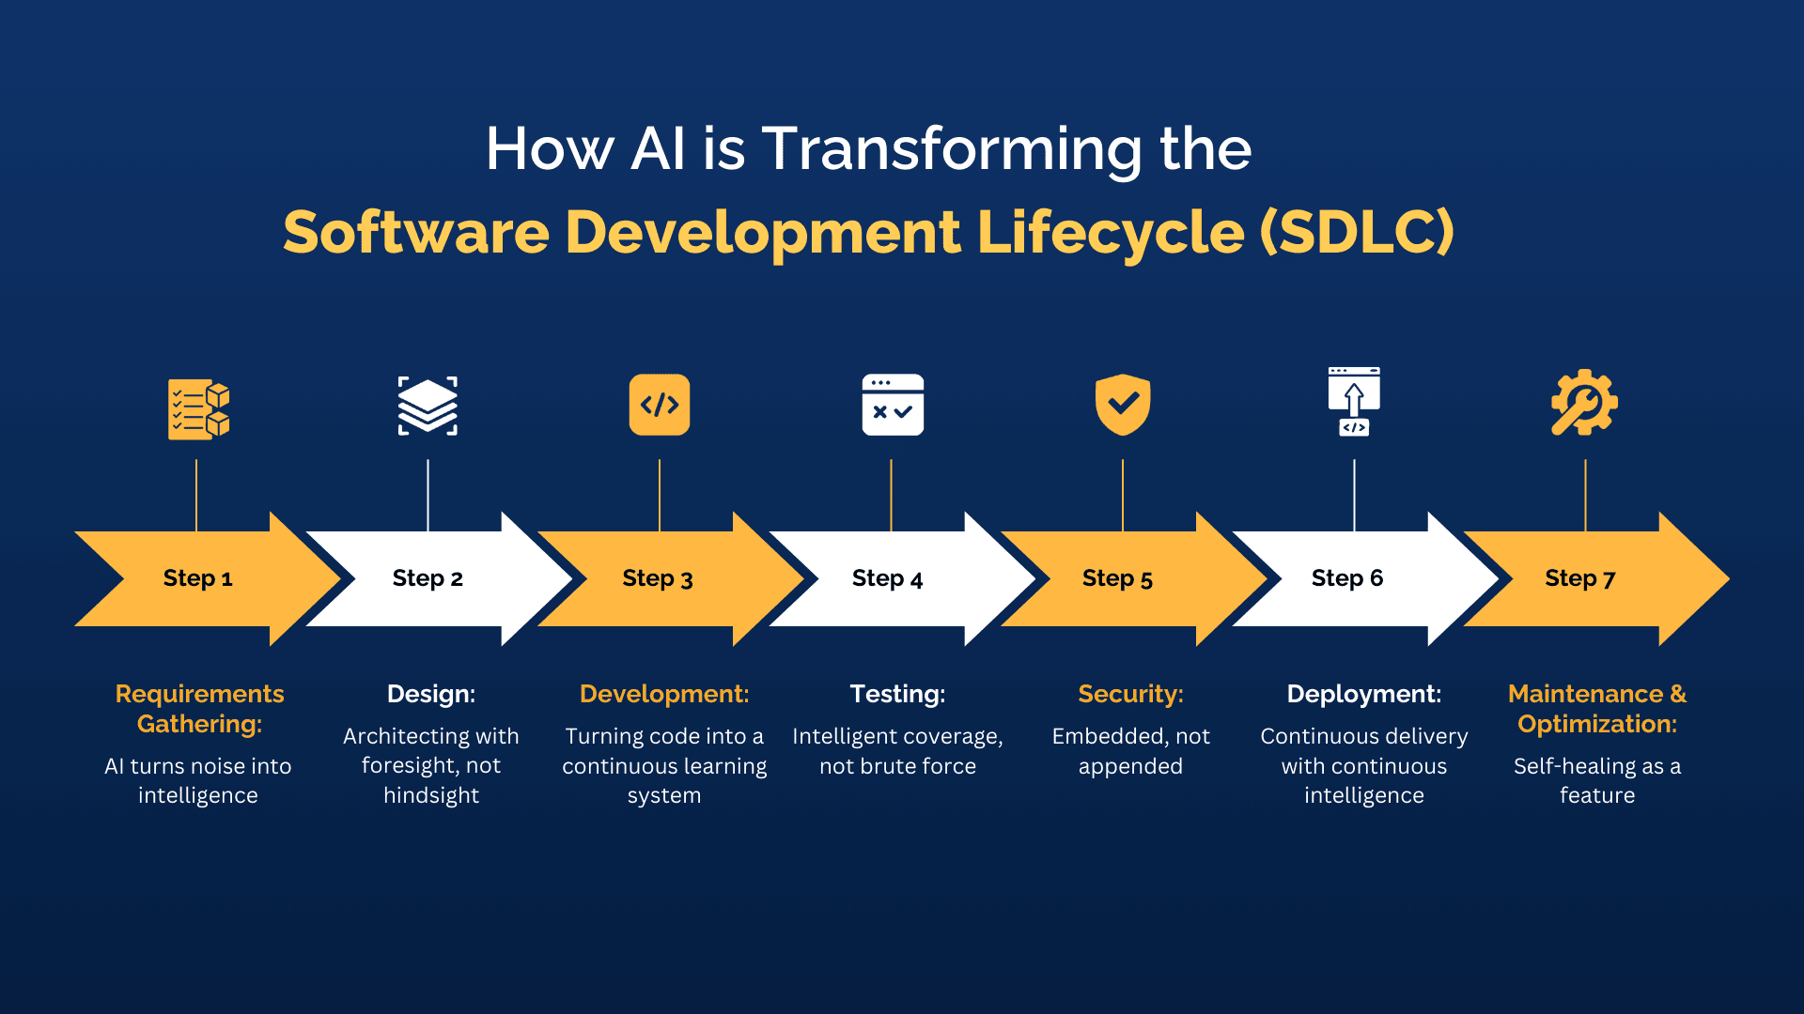

**Example Problem Statement for SmartSDLC**

**Customer Problem Statement:** "Software developers and students face difficulty converting software requirements into clear classifications, fixing bugs intelligently, and generating relevant starter code. These repetitive, manual tasks increase development time and reduce productivity. Currently, they rely on unstructured approaches and multiple platforms, resulting in inefficiencies. There is a growing need for an integrated, AI-enhanced SDLC tool like SmartSDLC to streamline these core activities and empower users to focus on innovation rather than repetitive tasks."